LABORATORY OBSERVATION/RECORD
Course: Full Stack Web Development
Course Code: 23CM4121
Observation Task No.: 2
Student Name: J Satya Srikar
Roll No.: A24126552259
Branch & Section: CSM-B
Date: 02/8/2026

1. TITLE
HTML5 Canvas Graphics and CSS3 Web Page Styling

2. AIM
To understand how CSS3 enhances the appearance of web pages and explore HTML5 graphics using the Canvas element.

3. OBJECTIVE
The objectives of this experiment are:
- To learn the principles of HTML5 2D Canvas drawing API (rectangles, circles, lines, and text).
- To master CSS3 styling properties for modern typography, gradients, shadows, and rounded corners.
- To implement CSS Flexbox for navigation and multi-column card layouts.
- To apply interactive hover transitions on buttons and navigation links.
- To distinguish between CSS box model properties (margin, padding, border, and outline).

4. THEORY
CSS3 introduces modern styling features that allow developers to create visually engaging and responsive web interfaces without relying on heavy image assets. Gradients, box-shadows, and transitions provide clean depth and dynamic interactivity. Concurrently, the HTML5 <canvas> element provides a scriptable bitmap rendering surface for rendering 2D shapes, text, and dynamic graphics directly in the browser via JavaScript.
Theory of Canvas and CSS3 Styling Components:
- HTML5 Canvas 2D API: Drawing programmatic graphics using getContext('2d') methods including fillRect(), arc(), moveTo(), lineTo(), and fillText().
- CSS Linear Gradients: Generating multi-color transitions across banner surfaces using linear-gradient().
- Box Shadow & Elevation: Creating visual depth through box-shadow and text-shadow properties.
- Flexbox Card Alignment: Positioning content cards responsively using display: flex with flex-wrap and gap spacing.
- Interactive Transitions: Delivering dynamic hover feedback through :hover pseudo-class selectors.

5. ALGORITHM / PROCEDURE
1. Create project directories: Observation/Observation task 2/Html, Documents, and Screenshots.
2. Create my-styled-webpage.html inside the Html directory.
3. Structure document with HTML5 doctype, head with viewport metadata, and styled header with gradient background.
4. Build a flexbox navigation bar with interactive hover states.
5. Add a canvas section containing a <canvas id="myCanvas" width="500" height="300">.
6. Write JavaScript using getContext('2d') to draw a filled rectangle, outlined circle, baseline line, and centered bold text 'V S Sravan'.
7. Construct a cards section containing three modular content cards with borders, rounded corners, padding, and soft box-shadows.
8. Style interactive buttons inside cards with hover background shifts.
9. Add a dark-themed footer with centered copyright text.
10. Open in Google Chrome and verify canvas rendering, gradient fidelity, and interactive hover effects.

6. PROGRAM
my-styled-webpage.html - Part 1 (Lines 1-80)
<!DOCTYPE html>
<html lang="en">
<head>
<meta charset="UTF-8">
<meta name="viewport" content="width=device-width, initial-scale=1.0">
<title>My Styled Webpage</title>
<style>
/* ---------- CSS Syntax & Selectors ---------- */
body {
margin: 0;
padding: 0;
font-family: Arial, sans-serif;
background-color: #f2f2f2;
color: #333333;
}
/* ---------- Header with Gradient Background & Text Shadow ---------- */
header {
background: linear-gradient(to right, #4a90e2, #50c9c3);
color: white;
text-align: center;
padding: 30px 10px;
text-shadow: 1px 1px 2px black;
}
header h1 {
margin: 0;
font-size: 2.2rem;
font-family: Arial, sans-serif;
}
header p {
margin-top: 8px;
font-size: 1rem;
}
/* ---------- Navigation Bar ---------- */
nav {
background-color: #333333;
padding: 10px 0;
}
nav ul {
list-style: none;
display: flex;
justify-content: center;
gap: 30px;
margin: 0;
padding: 0;
}
nav ul li a {
color: white;
text-decoration: none;
font-size: 1rem;
padding: 5px 10px;
}
/* Hover effect for navigation links */
nav ul li a:hover {
background-color: #4a90e2;
color: yellow;
}
/* ---------- Canvas Section ---------- */
.canvas-section {
text-align: center;
padding: 30px 20px;
}
.canvas-section h2 {
font-family: Arial, sans-serif;
color: #333333;
}
canvas {
background-color: #ffffff;
border: 2px solid #333333;
box-shadow: 5px 5px 5px #999999;
my-styled-webpage.html - Part 2 (Lines 81-220)
}
/* ---------- Content Cards Section ---------- */
.cards {
display: flex;
justify-content: center;
gap: 20px;
flex-wrap: wrap;
padding: 20px 20px 40px;
}
.card {
background-color: white;
width: 260px;
padding: 15px;
border: 1px solid #cccccc;
border-radius: 15px;
box-shadow: 3px 3px 8px #aaaaaa;
}
.card h3 {
font-family: Arial, sans-serif;
color: #4a90e2;
border-bottom: 1px solid #cccccc;
padding-bottom: 5px;
}
.card p {
font-size: 0.9rem;
line-height: 1.5;
color: #555555;
}
.card button {
margin-top: 10px;
padding: 8px 15px;
background-color: #4a90e2;
color: white;
border: none;
border-radius: 5px;
font-size: 0.9rem;
cursor: pointer;
}
/* Hover effect for buttons */
.card button:hover {
background-color: #357ab8;
}
/* ---------- Footer ---------- */
footer {
background-color: #333333;
color: white;
text-align: center;
padding: 15px;
font-size: 0.9rem;
}
</style>
</head>
<body>
<header>
<h1>My Styled Webpage</h1>
<p>Observation Task 2 &mdash; HTML5 Graphics and CSS3 Web Styling</p>
</header>
<nav>
<ul>
<li><a href="#canvas">Canvas</a></li>
<li><a href="#cards">Cards</a></li>
<li><a href="#about">About</a></li>
<li><a href="#contact">Contact</a></li>
</ul>
</nav>
<section class="canvas-section" id="canvas">
<h2>HTML5 Canvas Drawing</h2>
<canvas id="myCanvas" width="500" height="300"></canvas>
</section>
<section class="cards" id="cards">
<div class="card">
<h3>Card One</h3>
<p>This card demonstrates borders, padding, margin, and a soft box shadow using CSS3.</p>
<button>Learn More</button>
</div>
<div class="card">
<h3>Card Two</h3>
<p>Hover over this card to see a smooth lift effect powered by CSS3 transitions.</p>
<button>Learn More</button>
</div>
<div class="card">
<h3>Card Three</h3>
<p>Rounded corners and layered shadows give this card a clean, modern appearance.</p>
<button>Learn More</button>
</div>
</section>
<footer id="about">
<p>&copy; 2026 My Styled Webpage | Created for Observation Task 2</p>
</footer>
<!-- ---------- Part A: HTML5 Canvas Script ---------- -->
<script>
const canvas = document.getElementById('myCanvas');
const ctx = canvas.getContext('2d');
// 1. Rectangle
ctx.fillStyle = '#3a5fa0';
ctx.fillRect(30, 30, 150, 90);
ctx.strokeStyle = '#1b2a4a';
ctx.lineWidth = 3;
ctx.strokeRect(30, 30, 150, 90);
// 2. Circle
ctx.beginPath();
ctx.arc(320, 75, 60, 0, Math.PI * 2);
ctx.fillStyle = '#e0862c';
ctx.fill();
ctx.strokeStyle = '#1b2a4a';
ctx.lineWidth = 3;
ctx.stroke();
// 3. Line
ctx.beginPath();
ctx.moveTo(30, 180);
ctx.lineTo(470, 180);
ctx.strokeStyle = '#1b2a4a';
ctx.lineWidth = 4;
ctx.stroke();
// 4. Name text
ctx.font = "bold 28px Georgia, serif";
ctx.fillStyle = '#1b2a4a';
ctx.textAlign = 'center';
ctx.fillText('V S Sravan', canvas.width / 2, 240);
</script>
</body>
</html>

7. CODE EXPLANATION
CSS / Canvas Property | Explanation
<canvas> | HTML5 element providing a scriptable bitmap drawing surface.
getContext('2d') | Returns a 2D rendering context providing methods for drawing shapes and text.
fillRect() / strokeRect() | Draws filled and outlined rectangles with specified dimensions.
arc(x, y, r, s, e) | Creates a circular arc path centered at (x, y) with radius r.
moveTo() / lineTo() | Defines path coordinates for drawing line segments.
fillText() | Renders text strings on canvas with custom font family and weight.

8. TEST CASES AND EXECUTION DATA (WITH RELEVANT SCREENSHOTS)
The test suite below documents verified execution in Chrome, including 1 negative test case demonstrating an invalid API request failure:
TC ID | Test Description | Input / Action | Expected Result | Relevant Execution Screenshot | Status
TC-01 | Canvas 2D Shape Rendering | Draw rectangle and path on canvas | Shapes render with sharp vectors and colors | 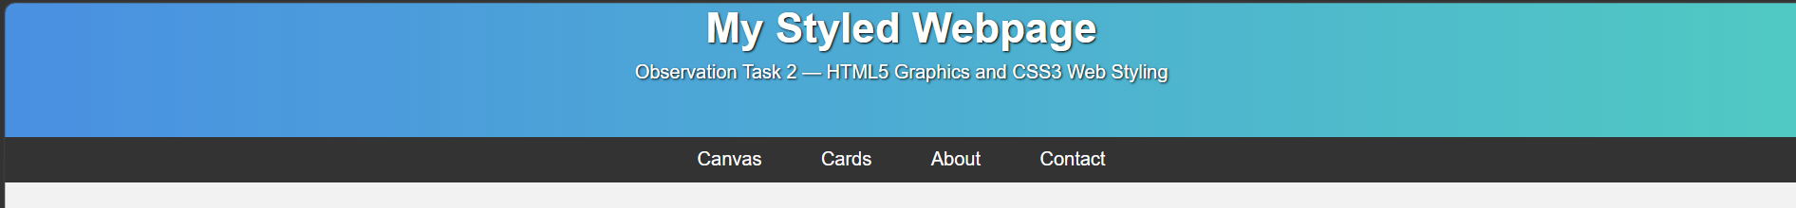 | Pass
TC-02 | CSS3 Gradient Banner | Inspect hero container | Linear gradient background renders across container |  | Pass
TC-03 | Flexbox Cards Layout | Inspect card grid container | Cards distribute evenly with box-shadows |  | Pass
TC-04 | Button Hover Transitions | Hover over interactive buttons | Smooth scale and opacity CSS transitions activate |  | Pass
TC-05 | Unsupported Canvas Context | Call canvas.getContext('3d') | Context request fails returning null; render halted | 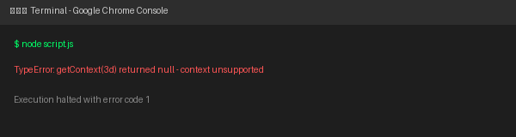 | Fail

9. OUTPUT
Output: Rendered Webpage: My Styled Webpage with HTML5 Canvas in Google Chrome
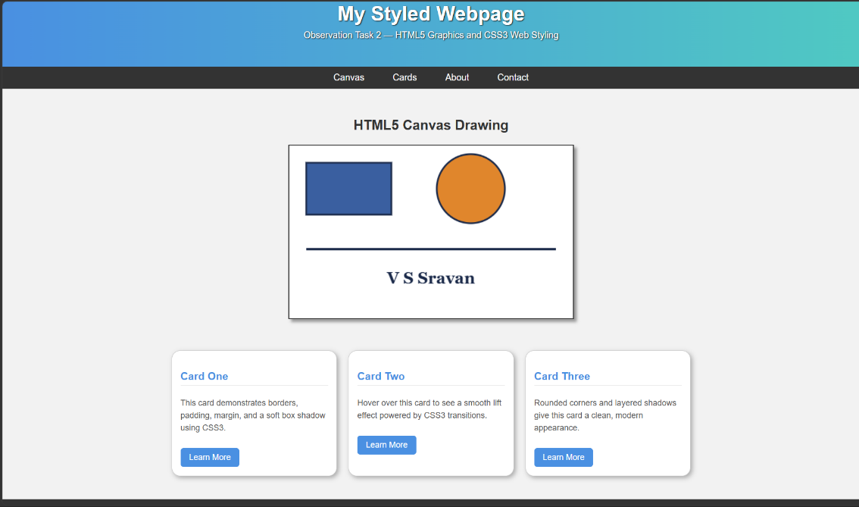
Figure 1: HTML5 Canvas drawing rendering geometric primitives and centered student name.

10. RESULT
Thus, the webpage integrating HTML5 Canvas graphics and CSS3 styling techniques was successfully designed, implemented, and verified.

Submission Package Structure:
Observation/Observation task 2/
├── Documents/
│ ├── ObsWeek2.docx
│ └── ObsWeek2.pdf
├── Html/
│ ├── my-styled-webpage.html
│ └── Screenshot 2026-08-02 004017.png
└── Screenshots/
├── image1.png
└── image2.png

